B1. What is C#?

Ans C# is pronounced "C-Sharp". It is an **object-oriented programming language** created by Microsoft that runs on the .NET Framework.

B2. Can we use keywords as a identifier? Why?

Ans Keywords are predefined, reserved words used in programming that have special meanings to the compiler. Keywords are part of the syntax and they**cannot** be**used as an identifier.**

B3. Create program to take 5 students details using structure

Ans

B5. Create program to sort string in descending order

Ans using System;

namespace Descending_Order

{

class Program

{

static void Main(string[] args)

{

int i, j;

int[] a = new int[20];

for (i = 0; i < 5; i++)

{

Console.WriteLine("enter the num" + " " + (i + 1) + ":");

a[i] = Convert.ToInt16(Console.ReadLine());

}

for (i = 0; i < 5; i++)

{

for (j = 0; j < 4; j++)

{

if (a[j] < a[j + 1])

{

int temp = a[j + 1];

a[j + 1] = a[j];

a[j] = temp;

}

}

}

Console.WriteLine("Descending Sort:");

for (i = 0; i < 5; i++)

{

Console.WriteLine(a[i] + "");

}

Console.ReadKey();

}

}

}

B6. Explain any 5 string operation methods

Ans

|  |  |
| --- | --- |
| Method Name | Description |
| [Clone()](https://www.javatpoint.com/csharp-string-clone) | It is used to return a reference to this instance of String. |
| [Compare(String, String)](https://www.javatpoint.com/csharp-string-compare) | It is used to compares two specified String objects. It returns an integer that indicates their relative position in the sort order. |
| [CompareOrdinal(String, String)](https://www.javatpoint.com/csharp-string-compareordinal) | It is used to compare two specified String objects by evaluating the numeric values of the corresponding Char objects in each string.. |
| [CompareTo(String)](https://www.javatpoint.com/csharp-string-compareto) | It is used to compare this instance with a specified String object. It indicates whether this instance precedes, follows, or appears in the same position in the sort order as the specified string. |
| [Concat(String, String)](https://www.javatpoint.com/csharp-string-concat) | It is used to concatenate two specified instances of String. |

B7. Create program to take 2 numbers from user and show maximum number

Ans using System;

namespace B7

{

class Program

{

static void Main(string[] args)

{

int a, b;

Console.WriteLine("Enter Any Two Number : ");

a = Convert.ToInt32(Console.ReadLine());

b = Convert.ToInt32(Console.ReadLine());

if (a>b)

{

Console.WriteLine(a);

}

else

{

Console.WriteLine(b);

}

}

}

}

B8

using System;

namespace B8

{

class Program

{

static void Main(string[] args)

{

int sum = 0,n , r;

Console.WriteLine("enter the number ");

n = Convert.ToInt32(Console.ReadLine());

while (n > 0)

{

r = n * n;

sum = r + sum;

n--;

}

Console.WriteLine("Total is : "+sum);

}

}

}

I5

using System;

namespace I5

{

class Program

{

static void Main(string[] args)

{

int a = 0, b = 1, c, n, i = 1;

Console.WriteLine("enter number for count series output :");

n = Convert.ToInt32(Console.ReadLine());

Console.WriteLine(a);

Console.WriteLine(b);

for ( i = 1; i <= n; i++)

{

c = a + b;

Console.WriteLine(c);

a = b;

b = c;

}

}

}

}

AI

using System;

namespace AI

{

class Program

{

static void Main(string[] args)

{

int sum = 0;

Console.Write("N : ");

int n = Convert.ToInt32(Console.ReadLine());

for (int i = 0; i <= n; i++)

{

sum = sum + i * i;

Console.WriteLine(sum

);

}

}

}

}

Pattern 1

using System;

namespace Pattern1

{

class Program

{

static void Main(string[] args)

{

int a,k;

Console.WriteLine("Enter Number To Draw Pattern : ");

a = Convert.ToInt32(Console.ReadLine());

//Console.WriteLine("-----------------------------");

k = 1;

for (int i = 1; i <= a; i++)

{

for (int j = 1; j <= i; j++ , k++)

{

Console.Write(k);

}

Console.WriteLine();

}

}

}

}

Pattern 2

using System;

namespace A2

{

class Program

{

static void Main(string[] args)

{

for (int i = 0; i < 5; i++)

{

for (int j = 0; j < i; j++)

{

if (i==1 || i==3 || i==5)

{

Console.Write(" * ");

}

else

{

Console.Write(" # ");

}

}

Console.WriteLine();

}

}

}

}

Pattern 3

using System;

namespace Pattern1

{

class Program

{

static void Main(string[] args)

{

int a;

Console.WriteLine("Enter Number To Draw Pattern : ");

a = Convert.ToInt32(Console.ReadLine());

for (int i = 1; i <= a; i++)

{

for (int j = 1; j <= i; j++)

{

Console.Write("*#");

}

Console.WriteLine();

}

}

}

}

Pattern 4

using System;

namespace Pattern1

{

class Program

{

static void Main(string[] args)

{

int a;

Console.WriteLine("Enter Number To Draw Pattern : ");

a = Convert.ToInt32(Console.ReadLine());

for (int i = 1; i <= a; i++)

{

for (int j = 1; j <= i; j++)

{

Console.Write("*");

}

Console.WriteLine();

}

}

}

}

Pattern 5

using System;

namespace Pattern1

{

class Program

{

static void Main(string[] args)

{

int a;

Console.WriteLine("Enter Number To Draw Pattern : ");

a = Convert.ToInt32(Console.ReadLine());

for (int i = 1; i <= a; i++)

{

for (int j = 1; j <= i; j++)

{

Console.Write(i);

}

Console.WriteLine();

}

}

}

}

Pattern 6

using System;

namespace Pattern1

{

class Program

{

static void Main(string[] args)

{

int a;

Console.WriteLine("Enter Number To Draw Pattern : ");

a = Convert.ToInt32(Console.ReadLine());

for (int i = 1; i <= a; i++)

{

for (int j = 1; j <= i; j++)

{

Console.Write(j);

}

Console.WriteLine();

}

}

}

}

B9. What do you mean by loop variable?

Ans In for loop, a **loop** variable is used to control the loop. First initialize this loop variable to some value, then check whether this variable is less than or greater than counter value. If statement is true, then loop body is executed and loop variable gets updated.

B10. What do you mean by interation?

Ans An interface is a completely "**abstract class**", which can only contain abstract methods and properties (with empty bodies)

B11. What is Array?

Ans An array is a group of like-typed variables that are referred to by a common name. And each data item is called an element of the array. The data types of the elements may be any valid data type like char, int, float, etc. and the elements are stored in a contiguous location.

B12. Show ASCII value of entered number

Ans using System;

namespace B12

{

class Program

{

static void Main(string[] args)

{

string str ;

Console.WriteLine(" Enter Value For ASCII : ");

str = Console.ReadLine();

foreach (var c in str)

{

Console.WriteLine((int)c);

}

}

}

}

B13. What is jagged array? Explain with example

Ans Jagged array is a**multidimensional array where member arrays are of different size**. For example, we can create a 2D array where first array is of 3 elements, and is of 4 elements.

B15. Write a program to call class method.

Ans using System;

namespace B15

{

class yash

{

string a = "YASH NAKRANI";

public void show()

{

Console.WriteLine("YASH NAKRANI");

}

}

class Program

{

static void Main(string[] args)

{

yash e = new yash();

e.show();

}

}

}

B16. Write a program to calculate arithmetic operations using class and object.

Ans using System;

namespace B16

{

class arithmetic

{

int a,b,c;

public void getdata()

{

Console.WriteLine("ENTER TWO VALUE :");

a = Convert.ToInt32(Console.ReadLine());

b = Convert.ToInt32(Console.ReadLine());

}

public void add()

{

c = a + b;

Console.WriteLine(" addtion of two number is : "+ c);

}

public void sub()

{

c = a - b;

Console.WriteLine(" subtraction of two number is : " + c);

}

public void mul()

{

c = a * b;

Console.WriteLine(" multipilcation of two number is : " + c);

}

public void div()

{

c = a / b;

Console.WriteLine(" divsion of two number is : " + c);

}

}

class Program

{

static void Main(string[] args)

{

arithmetic e = new arithmetic();

e.getdata();

e.add();

e.sub();

e.mul();

e.div();

}

}

}

B17. Write a program to call method of parent class.

Ans using System;

namespace B17

{

class yash

{

string str = "yash";

}

class Program

{

static void Main(string[] args)

{

yash e = new yash();

}

}

}

B18. Write a program to get three subject marks details and then show average and sum.

Ans using System;

namespace B18

{

class marks

{

int maths;

int sci;

int ss;

float average;

int sum;

public void getdata()

{

Console.WriteLine("Enter Marks Of Maths");

maths = Convert.ToInt32(Console.ReadLine());

Console.WriteLine("Enter Marks Of sci");

sci = Convert.ToInt32(Console.ReadLine());

Console.WriteLine("Enter Marks Of SS");

ss = Convert.ToInt32(Console.ReadLine());

}

public void show()

{

sum = maths + sci + ss;

average = (maths + sci + ss) / 3;

Console.WriteLine("TOTAL MARKS : {0}",sum);

Console.WriteLine("AVERAGE MARKS : {0}", average);

}

}

class Program

{

static void Main(string[] args)

{

marks m = new marks();

m.getdata();

m.show();

}

}

}

B19. Write a program to calculate factorial number of userdefined value using class.

Ans using System;

namespace B19

{

class fact

{

int f,a=1;

public void fac()

{

Console.WriteLine("Enter Value For Factorial : ");

f = Convert.ToInt32(Console.ReadLine());

for (int i = 1; i <= f; i++)

{

a = a * i;

Console.WriteLine("{0}",a);

}

Console.WriteLine("factorial : {0}",a);

}

}

class Program

{

static void Main(string[] args)

{

fact e = new fact();

e.fac();

}

}

}

B20. Write a program to perform an example of data hiding.

Ans using System;

namespace B20

{

class Class1

{

public void display()

{

Console.WriteLine("Super class display method");

}

}

class Class2 : Class1

{

public new void display()

{

Console.WriteLine("Sub class display method");

}

}

class Program

{

static void Main(string[] args)

{

Class2 obj = new Class2();

obj.display();

Console.ReadKey();

}

}

}

B21. How can we manage runtime errors?

Ans Using exception handling, we can handle exception in a proper way and show the accurate result as per user understanding. It is a mechanism to detect and **handle** run time errors.

B22. What is abstract class?

Ans An abstract class is a**special class in C# that cannot be instantiated**, The purpose of an abstract class is to provide a skeletal structure for other classes to derive from. Abstract classes have no implementation of their own.

B23. What is thread?

Ans a multi-threading system is built upon the Thread class, which encapsulates the execution of threads. This class contains several methods and properties which helps in managing and creating threads and this class is defined under System.Threading namespace.

B24. What is dll?

Ans A Dynamic Link library (DLL) is a library that contains functions and codes that can be used by more than one program at a time. Once we have created a DLL file, we can use it in many applications. The only thing we need to do is to add the reference/import the DLL File. Both DLL and .exe files are executable program modules but the difference is that we cannot execute DLL files directly.

B25. What is namespace?

Ans A namespace is designed for providing a way to keep one set of names separate from another. The class names declared in one namespace does not conflict with the same class names declared in another.

27. Create program to replace specific word from string

Ans using System;

namespace _27

{

class Program

{

static void Main(string[] args)

{

char a='a';

string str = a.ToString();

Console.WriteLine(" enter word to convert to string : ");

a = (char)Convert.ToInt32(Console.ReadLine());

}

}

}

28. Create program to take 3 numbers from user and show maximum and minimum number

Ans using System;

namespace _28

{

class Program

{

static void Main(string[] args)

{

int a, b, c , max , min ;

Console.WriteLine("Enter Three Number : ");

a = Convert.ToInt32(Console.ReadLine());

b = Convert.ToInt32(Console.ReadLine());

c = Convert.ToInt32(Console.ReadLine());

Console.WriteLine("MAXIMUM NUMBER = " + Math.Max(Math.Max(a, b), c));

Console.WriteLine("MINIMUM NUMBER = " + Math.Min(Math.Min(a, b), c));

}

}

}

29. What is difference between else if ladder and switch case

Ans 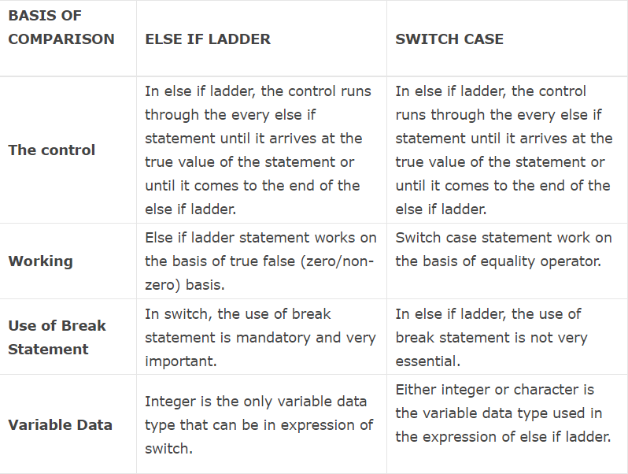

30. What will occur if we not write break statement in switch case?

Ans Switch case statements are used to execute only specific case statements based on the switch expression. If we do not use break statement at the end of each case,**program will execute all consecutive case statements** until it finds next break statement or till the end of switch case block.

31. What is difference between entry loop and exit loop? Explain with example

Ans **Entry** controlled loops are used when checking of test condition is mandatory before executing loop body, whereas exit controlled is used when checking of test condition is mandatory after executing. For loop, Foreach loop and while loops are examples of entry controlled loops, whereas do-while loop is an example of exit controlled loop.

32. What do you mean by multi-dimension array?

Ans A data structure consisting of a vector of vectors, in the case of a 2-dimensional array, or, in the case of an N-dimensional array, a vector of multidimensional arrays of degree N minus 1, thereby allowing the simulation of a N-dimensional grid of storage locations using an underlying memory architecture in which storage is addressed in a linear fashion.

33. Explain 5 method of array class with example

Ans 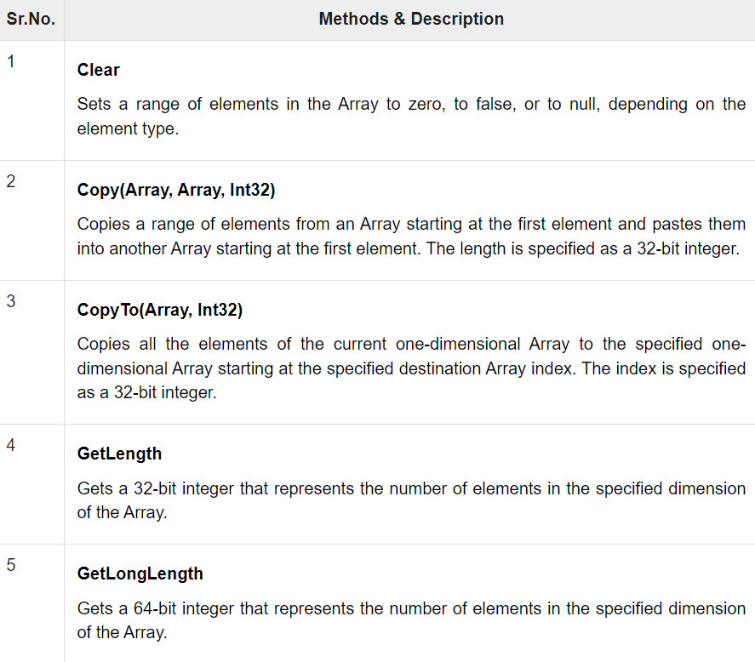

34. Get 5 values from user and store in array and show all elements and sum of elements

Ans using System;

namespace _34

{

class Program

{

static void Main(string[] args)

{

int[] a = new int[100];

int sum = 0;

Console.WriteLine("Enter Any Five Number : ");

for (int i = 0; i < 5; i++)

{

a[i] = Convert.ToInt32(Console.ReadLine());

}

for (int i = 0; i < 5; i++)

{

sum += a[i];

}

Console.WriteLine("TOTAL = "+sum);

}

}

}

35. Create program to make transform of two matrices

Ans

36. What is difference between for loop and foreach loop?

Ans

## For Loops:

For loops are appropriate loops when you know exactly how many times iteration you wants in statements within the loop.

For loop iterates a statement or a block of statements repeatedly until a specified expression evaluates to false.

## **ForEach Loops**

For-each loop is used to iterate through the items in object collections, List generic collections or array list collections.

37. Write a program to call static method using class.

Ans using System;

namespace _37

{

static class data

{

static string name;

static string lang;

static int id;

public static void getdata()

{

Console.WriteLine("Enter Name : ");

name = Console.ReadLine();

Console.WriteLine("Enter Language : ");

lang = Console.ReadLine();

Console.WriteLine("Enter ID : ");

id = Convert.ToInt32(Console.ReadLine());

}

}

class Program

{

static void Main(string[] args)

{

data.getdata();

}

}

}

38. Write a program to implement multilevel inheritance.

Ans using System;

namespace _38

{

class get

{

public void computer()

{

Console.WriteLine("computer stock - 10");

}

}

class get2 : get

{

public void laptop()

{

Console.WriteLine("laptop stock - 15");

}

}

class get3 : get2

{

public void moblie()

{

Console.WriteLine("laptop stock - 56");

}

}

class Program

{

static void Main(string[] args)

{

get3 g = new get3();

g.computer();

g.laptop();

g.moblie();

}

}

}

39. Write a program to get 10 Employee details including name, salary, department and show name and designation whose salary is highest.

Ans using System;

namespace _39

{

class employee

{

string name;

string department;

int salary;

int sum=0;

private byte salry;

public void getdata()

{

for (int i = 0; i < 10; i++)

{

Console.WriteLine("employee name {0}:" , i);

name = Console.ReadLine();

Console.WriteLine("department :");

department = Console.ReadLine();

Console.WriteLine("salary per month :");

salary = Convert.ToInt32(Console.ReadLine());

sum = Math.MaxMagnitude(salary);

}

}

}

class Program

{

static void Main(string[] args)

{

employee e = new employee();

e.getdata();

}

}

}

41. Write a program to redefine method logic in child class. (Overloading)

Ans using System;

namespace _41

{

class sum

{

public void add(int a,int b)

{

int c = a + b;

Console.WriteLine("addtion : "+c);

}

public void add(int a,int b, int c)

{

int d = a + b + c;

Console.WriteLine("addtion of three no : "+d);

}

}

class Program

{

static void Main(string[] args)

{

sum s = new sum();

s.add(10, 20);

s.add(10, 20, 30);

}

}

}

42. Write a program to access private variables outside of class.

Ans using System;

namespace _42

{

class private_var

{

private int i = 10;

public void display()

{

Console.WriteLine("private varable = "+i);

}

}

class Program

{

static void Main(string[] args)

{

private_var p = new private_var();

p.display();

}

}

}

44. What is dictionary? Advantages of Dictionary?

Ans a book that will help to know the meaning of word. There are dictionaries that is help to get the meaning of the word in the same language or the other language. Dictionary help us to know the meaning of words from other language.

45. What is multithread?

Ans Multitasking is the simultaneous execution of multiple tasks or processes over a certain time interval. Windows operating system is an example of multitasking because it is capable of running more than one process at a time like running Google Chrome, Notepad, VLC player, etc. at the same time. The operating system uses a term known as a process to execute all these applications at the same time. A process is a part of an operating system that is responsible for executing an application. Every program that executes on your system is a process and to run the code inside the application a process uses a term known as a thread.

46. How to prevent class to be instantiate?

Ans There are a few ways prevent instantiation of a class. Let's proceed to dig into this so that my geeks can have an idea of this. Those ways are: Abstract Static Class Private and protected constructor Now jump to Abstract classes first. 1. Abstract An abstract class is the one that is not used to create objects.

47. Create program to replace specific character from string

Ans using System;

namespace _47

{

class Program

{

static void Main(string[] args)

{

char a='a';

string str = a.ToString();

Console.WriteLine(" enter word to convert to string : ");

a = (char)Convert.ToInt32(Console.ReadLine());

}

}

}

48. What is mutable and immutable string?

* Ans Mutable string. StringBuilder is a mutable string in C#. With StringBuilder, you can expand the number of characters in the string.
* Example
* Output
* Immutable string. Immutable string is a String in C#. A new memory is created every time. A String cannot be changed once it is created, unlike StringBuilde.
* Example. Steve and Ben are not equal strings.

49. Write a program to find factorial of user defined number

Ans using System;

namespace 49

{

class fact

{

int f,a=1;

public void fac()

{

Console.WriteLine("Enter Value For Factorial : ");

f = Convert.ToInt32(Console.ReadLine());

for (int i = 1; i <= f; i++)

{

a = a * i;

Console.WriteLine("{0}",a);

}

Console.WriteLine("factorial : {0}",a);

}

}

class Program

{

static void Main(string[] args)

{

fact e = new fact();

e.fac();

50. Write a program to sort a numeric array without using array methods.

Ans using System;

using System.Collections.Generic;

class sort_example

{

static void Main()

{

List<int> sort_list = new List<int>();

sort_list.Add(11);

sort_list.Add(31);

sort_list.Add(5);

sort_list.Add(1);

sort_list.Add(562);

sort_list.Add(786);

sort_list.Add(564);

sort_list.Add(541);

System.Console.WriteLine("List Before");

foreach (int num in sort_list)

{

System.Console.WriteLine(num);

}

sort_list.Sort();

System.Console.WriteLine("\n" + "List After" + "\n");

foreach (int num in sort_list)

{

System.Console.WriteLine(num);

}

Console.ReadLine();

}

}

51. What is difference between array and list?

Ans One of the major differences is that List is an interface and ArrayList is a class of Java Collection framework.

The List extends the collection framework, comparatively ArrayList extends AbstractList class and implements the List interface.

The namespace for the List and ArrayList is System.Collection.Generic and System Collection, respectively

52.

53. Get 5 values from user and show maximum value from array

Ans using System;

namespace _53

{

class Program

{

static void Main(string[] args)

{

int[] arr = new int[5];

int i, max, min, n;

// size of the array

Console.WriteLine("enter the quantity of array number : ");

n = Convert.ToInt32(Console.ReadLine());

for (int j = 0; j < n; j++)

{

Console.WriteLine("enter value array : "+j);

arr[j] = Convert.ToInt32(Console.ReadLine());

}

max = arr[0];

min = arr[0];

for (i = 1; i < n; i++)

{

if (arr[i] > max)

{

max = arr[i];

}

if (arr[i] < min)

{

min = arr[i];

}

}

Console.Write("Maximum element = {0}\n", max);

Console.Write("Minimum element = {0}\n\n", min);

}

}

}

54. Write a program to define base class with fixed method signature and implement them into derived class. (Abstract Class)

Ans using System;

namespace _54

{

class Program

{

abstract class demo

{

public abstract void getdata();

public void showdata()

{

Console.WriteLine("showing SHOWDATA");

}

}

class yas : demo

{

public override void getdata()

{

Console.WriteLine("showing GETDATA");

}

}

static void Main(string[] args)

{

yas y = new yas();

y.getdata();

y.showdata();

}

}

}

57. Write a program to Get 10 random numbers using parent class's constructor and implement one method in derived class to show them in ascending manner.

Ans using System;

namespace _57

{

class ran

{

internal int[] a = new int[10];

public ran()

{

for (int i = 0; i < 10; i++)

{

Console.WriteLine("Enter NO.{0} value : ", i);

a[i] = Convert.ToInt32(Console.ReadLine());

}

}

}

class Yash : ran

{

public void show()

{

for (int i = 0; i < 10; i++)

{

Array.Sort(a);

Console.WriteLine("the number in order {0} ", a[i]);

}

}

}

class Program

{

static void Main(string[] args)

{

Yash y = new Yash ();

y.show();

}

}

}

60. Write a program to show details of 10 products including Product Name, Product Price, Qty to user and provide them ability to make order with qty and show final amount of bill.

Ans using System;

namespace _60

{

class Program

{

static void Main(string[] args)

{

int a = 1;

Console.WriteLine("");

Console.WriteLine("1. MOBLIE");

Console.WriteLine("2. LAPTOP");

Console.WriteLine("3. CAMERA");

Console.WriteLine("4. WATCH");

Console.WriteLine("5. SMART WATCH");

Console.WriteLine("6. KEYBORD");

Console.WriteLine("7. MOUSE");

Console.WriteLine("8. HARD DISK");

Console.WriteLine("9. SSD");

Console.WriteLine("10. MONITOR");

Console.WriteLine("");

Console.WriteLine("enter number ");

a = Convert.ToInt32(Console.ReadLine());

if (a > 1)

{

}

else

{

Console.WriteLine("invalid input");

}

Console.WriteLine("");

Console.WriteLine("")

;

switch (a)

{

case 1:

Console.WriteLine("MOBLIE");

Console.WriteLine("PRIZE = 20,000");

break;

case 2:

Console.WriteLine("LAPTOP");

Console.WriteLine("PRIZE = 50,000");

break;

case 3:

Console.WriteLine("CAMERA");

Console.WriteLine("PRIZE = 70,000");

break;

case 4:

Console.WriteLine("WATCH");

Console.WriteLine("PRIZE = 40,000");

break;

case 5:

Console.WriteLine("SMART WATCH");

Console.WriteLine("PRIZE = 60,000");

break;

case 6:

Console.WriteLine("KEYBORD");

Console.WriteLine("PRIZE = 1,000");

break;

case 7:

Console.WriteLine("MOUSE");

Console.WriteLine("PRIZE = 500");

break;

case 8:

Console.WriteLine("HARD DISK");

Console.WriteLine("PRIZE = 3,000");

break;

case 9:

Console.WriteLine("SSD");

Console.WriteLine("PRIZE = 5,000");

break;

case 10:

Console.WriteLine("MONITOR");

Console.WriteLine("PRIZE = 5,000");

break;

}

}

}

}

61. Create a program to store student’s details using Dictionary

Ans using System;

using System.Collections.Generic;

namespace _61

{

class Program

{

static void Main(string[] args)

{

Dictionary<int, Object> dic = new Dictionary<int, object>();

dic.Add(1, "yash");

dic.Add(2, "jash");

dic.Add(3, "parth");

dic.Add(4, "vidhan");

dic.Add(5, "vinit");

dic.Add(6, "jemin");

foreach (var item in dic)

{

Console.WriteLine(item.Key + " : " + item.Value);

Console.WriteLine();

}

Console.Read();

}

}

}

62. What is generics? Explain with example

Ans Generics in Java is similar to templates in C++. For example, classes like HashSet, ArrayList, HashMap, etc use generics very well. There are some fundamental differences between the two approaches to generic types. Like C++, we use <> to specify parameter types in generic class creation.

63. What is use of method overriding?

Ans Method Overriding in C# is similar to the [virtual function in C++](https://www.geeksforgeeks.org/virtual-function-cpp/). Method Overriding is a technique that allows the invoking of functions from another class (base class) in the derived class. Creating a method in the derived class with the same signature as a method in the base class is called as method overriding.